**HISTON BAPTIST CHURCH: PROFILE**

**How we see our church and its place within the community**

Updated April 2025

Village Setting

Histon Baptist Church is set centrally in the combined villages of Histon and Impington. It is situated north of Cambridge with excellent bus and guided bus services to the city. It also has easy access to the A14 and M11. It is almost a suburb of Cambridge but has retained its rural village character being separated from the rest of Cambridge by the A14.

Histon & Impington has a population of approximately 11,000, with excellent amenities. The village has provision for pre-school, primary and secondary, including a sixth form. There are five Churches within the village: two Parish, one Methodist, one Salvation Army, and our Baptist Church. There is good relationship between the Ministers and the Churches, which has resulted in a number of annual outreach events including: a Light Party, Carols on the Green, Good Friday events for young families and a Holiday Club.

Property in the village is expensive, which tends to attract professionals and retirees, although the congregation generally covers a much broader spectrum.

Brief Description and Membership Profile

We are a lively, active, evangelical church, and a member of the Baptist Union. Our Mission Statement is “Connecting people to Jesus Christ and to each other”. We seek to do this through worship, teaching, regular activities, outreach events, and building good relationships in the community.

The church is led by our pastor, the Revd Chris Farmer, who was appointed in September 2021, and lives with his wife and children in the church manse, which is next door to the church. He is supported in his role by a team of 3 Elders and 7 Deacons, who are elected by the church members. One of the deacons is the church treasurer and another looks after the church admin.

The church currently has 120 members plus a good number of other people who attend services on a regular basis. We also broadcast the Sunday service on Zoom, for those not able to attend in person. The age demographic of our church ranges from babies to the elderly, with the most dominant age group being those in their 50’s-60’s, and the least represented being those in their 20’s-30’s. Over recent years the church fellowship has seen growth in different nationalities, including Brazilian, Indian, Chinese, Nigerian, Romanian, Hungarian, South African and Lithuanian. It has also welcomed a good number of people with physical and learning difficulties.

On Wednesday afternoons a Welcome Cafe is run in the coffee area and church hall. This is open to everybody, and provides a friendly environment for enjoying a drink and a chat.

Children are well catered for, there being a creche and Sunday school group on Sunday mornings, and a toddler group which meets regularly on a Thursday morning in term-time.

There is a lively youth group which meets on a Friday evening (25-30 people), with some attending the Sunday service. The current youth work is run by a team of volunteers who help with the organisation and running of events.

The church is also home to a young people’s singing and drama group called Tensing, which meets on a Thursday evening during term-time.

Sunday Worship

We hold a service every Sunday morning at 10.30 a.m. with a regular congregation of 100 – 150. This normally lasts for about an hour and a quarter. Once a month communion is incorporated into the service. We have a team of people who take turns in leading the worship, with the Pastor normally bringing the teaching. We also have other members who preach when the Pastor is away. Members of the congregation participate in giving the Bible reading and leading intercessory prayers. The music is mainly contemporary, with occasional use of older hymns where appropriate, led by a music group. The words of all songs are projected onto an overhead screen, and the Music Group are “mixed” via the AV system. We also have an organ, but this is used less frequently now. We have a Worship Planning Group that meets regularly.

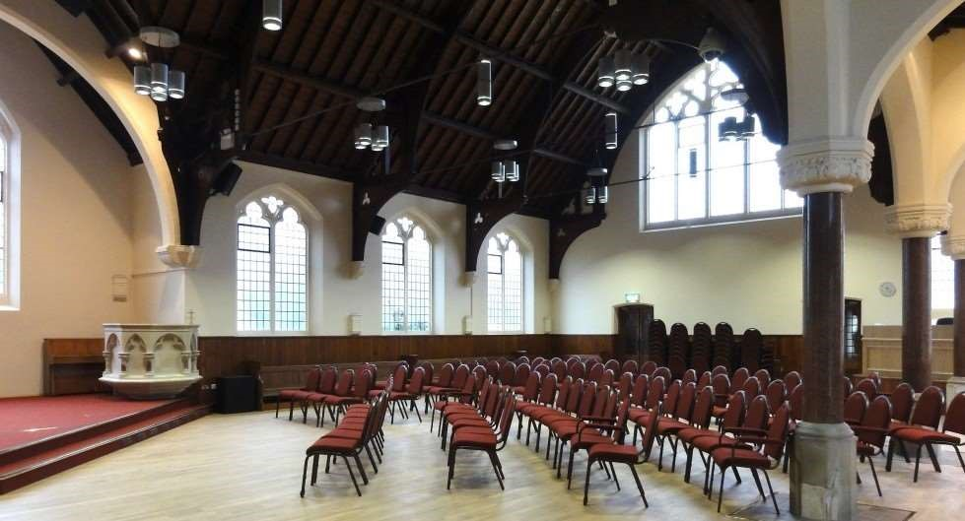

The Sunday service is also broadcast via Zoom. This is something which the church started during Covid times, and has decided to continue, as it meets the need of a small group in the church family who are unable to attend in person.

The Sunday sermons are also posted each week to the church website, from where they may be listened to or downloaded.

The children and young people usually remain in the service for the first half hour and then go to other rooms for their own sessions, by age group (Creche, Motivators and Explorers). Every few months we run a shorter ‘All-In’ service where everybody remains in the service and then stays afterwards for lunch and/or activities. We continue to look for creative ways of including and encouraging all-ages to serve and use their gifts in the weekly services we run.

After the service, we have a Prayer Corner where anyone can go if they need prayer, and we also serve tea/coffee/biscuits etc. for all in the Coffee Area. This is a good time to catch up with people and to welcome newcomers.

We do not hold a regular Sunday evening service, but once a month there have been a number of evening services, which the young people have helped lead. From mid-January 2025 we will be running an Alpa Course on Sunday evenings.

History

There has been a Baptist church in the villages since 1858, when on April 16th of that year, a meeting was held in Histon to consider the possibility of forming a Baptist church in the village, and a piece of land facing the village green, was made available for a Baptist chapel. Initial Baptist meetings on Sundays were held in a clubroom of the ‘Rose & Crown’ public house, and then on 14th September 1858 the chapel was completed and opened for worship.

With a growth in the village population towards the end of the nineteenth century, in part due to the expansion of Chivers and Sons whose workforce had reached 2,000, discussions took place about larger chapel premises. At a church meeting in March 1899 Stephen Chivers announced that he would donate land on Station Road for the building of a new chapel and Sunday School building, and members of the Chivers family between them pledged money towards the construction costs.  This formed the main part of the premises which is still in use today.

Premises

We are blessed with good-sized premises, comprising the main worship area and adjacent halls with recently updated kitchen facilities, and an inner courtyard. The worship area was extensively refurbished in 2010, with an extended rostrum area for leading worship, and comfortable chairs to replace most of the pews, making it more versatile. The Church is set in very pleasant grounds, with a large lawn at the front and a car park. Volunteers look after the maintenance and gardening, and the church Eco Group work hard to ensure it is an eco-friendly environment.

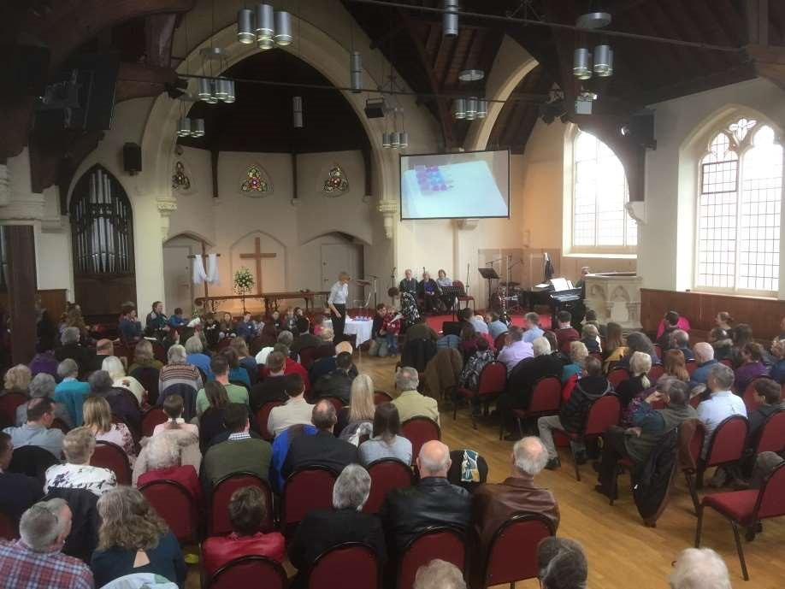

Weekly Church Activities

|  |  |
| --- | --- |
| Youth Club | Every Friday evening in term-time |
| Ten Sing | Teenage group for music, drama and fun, every Thursday in term-time |
| The Ark | Parents/Carers and Toddlers Group, every Thursday in term-time |
| Music Group Practice | Every Thursday or Friday evening |
| Life Groups | Small groups, for bible study and prayer (meet fortnightly) |
| Women’s Bible Study | Two groups with 6-10 attendees (meet fortnightly) |

Monthly Church Activities:

Church Members’ Meeting Every 2 months

|  |  |
| --- | --- |
| Church Prayer Meeting | One in person meeting (Tuesday), one on Zoom (Wednesday) each month |

Annual Activity:

July Holiday Club To connect with children in the village. Combined outreach activity with all the Churches in the village, usually held on our premises

Community Use of Premises:

The church premises are also used widely by local groups, including:

Slimming World

Choir 2000 (a local choir)

Rainbows

Brownies

Pilates

Country Market (the local Histon & Impington group selling crafts and food items)

Quartet Club of Cambridge (a local string quartets group)

GenR8 (web site <https://genr8.org/> )

Connections Bus Project (web site <https://www.connectionsbusproject.org.uk/what-we-do> )

John Hardwick (web site <https://www.johnhardwick.org/> )

GenR8, Connections Bus Project and John Hardwick (who all work with Children & Young People) also have offices within the premises.

We seek to have a good relationship with all the above groups, and, when appropriate, actively invite them to any exploratory courses that we are running.

Pastoral Care

We have a good Pastoral Care System in the Church, with a team who meet together regularly to manage the overall pastoral needs. There is a larger group of “Church Friends” who each look after a small group of people in the fellowship, both members and attendees, by befriending, visiting and spotting any particular needs. We also have an organised system of supplying cooked meals to people when there is a need.

Safety Protection Policies

We operate a Safeguarding Policy for children, young people and adults, with each area having Designated Persons for Safeguarding. Many members of the church have recently undergone Safeguarding Level 2 and Level 3 training.

Mission

We have a Missions Committee and our mission outreach supports the following:

BMS

Home Mission

GenR8

John Hardwick

Youth for Christ

Compassion UK (individual members of our congregation sponsor children through this charity)

Social/Outreach Activities:

We arrange various social events during the year such as a Christmas Pudding event, Remembrance Sunday Café, Welcome Café, Christmas and Easter events, along with Churches Together events such as Light Party and Holiday Club.

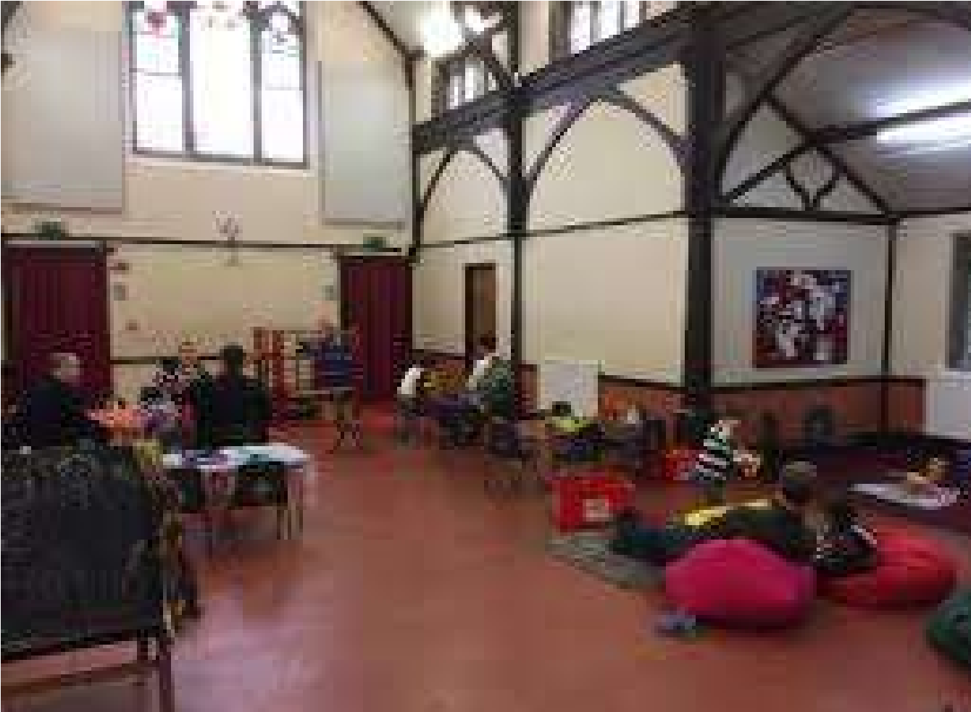

The church also has connections with many local charities and organisations including:  
[HI](https://histonbaptist.org.uk/Groups/285683/Local_Connections.aspx#The%20Day%20Centre) Friends  
[Cambridge Street Pastors](https://histonbaptist.org.uk/Groups/285683/Local_Connections.aspx#Cambridge%20Street%20Pastors)  
[Afrinspire](https://histonbaptist.org.uk/Groups/285683/Local_Connections.aspx#Afrinspire)  
[Eastern Baptist Association](https://histonbaptist.org.uk/Groups/285683/Local_Connections.aspx#Eastern%20Baptist%20Association)  
[Baptists Together](https://histonbaptist.org.uk/Groups/285683/Local_Connections.aspx#Baptist%20Together)

SIM UK

Finances

The Church is at present in a strong financial position. The Church Treasurer is supported by a Finance Team which meets regularly.

Further Information

Further information about Histon Baptist Church can be found on the church website at <https://histonbaptist.org.uk/> and any queries should be addressed to the church administrator at [admin@histonbaptistchurch.org.uk](mailto:admin@histonbaptistchurch.org.uk)